**IBM ASSIGNMENT – 2**

Python Programming

|  |  |
| --- | --- |
| Assignment Date | 07 October 2022 |
| Student Name | Suriya K |
| Student Roll Number | 953319104031 |

**Build a python code, Assume u get temperature and humidity values (generated with random function to a variable) and write a condition to continuously detect alarm in case of high temperature.**

**CODE:**

import random

def temperature():

value=random.randint(25,100)

return value

t=temperature()

t=int(input("Enter the temperature value: "))

def humidity():

range=random.randint(40,100)

return range

h=humidity()

h=int(input("Enter the humidity value: "))

#for temperature

if(t>30):

print("High temperature is detected")

print("Buzzer on,alarm sound is high")

elif(t==30):

print("Temperature reached maximum")

else:

print("Temperature is good")

#for humidity

if(h>65):

print("High Humidity is detected")

print("Buzzer on,alarm sound is high")

elif(h==65):

print("Humidity reached maximum")

else:

print("Humidity is good")

**PROGRAM:**

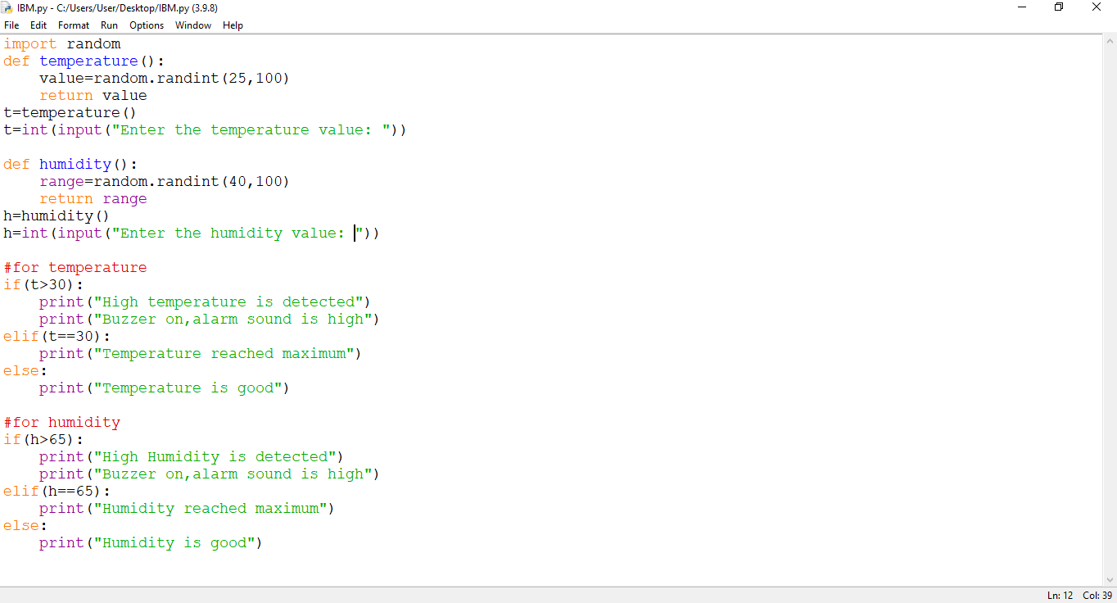

**OUTPUT:**

